 PROJECT REPORT
SIMPLE X AND O GAME
Project title : | Simple X and O Game
Course title : | Programming in Python
Course code : | CSE 1021
Course type : | Flipped course
Course credits : | 3
Professor : | Dr. Saravanan . D
Slot : | F11 + F12
Submitted by : | Bharathi Krishana . A
Registration number : | 26BAI10834
Submission date : | 30/9/2026

INTRODUCTION
The Simple X and O Game is a two-player command-line game developed in Python. It uses a 3×3 board where players X and O take turns placing their marks.
The project demonstrates lists, functions, loops, conditional statements, input validation, exception handling and logical comparison.

PROBLEM STATEMENT
A console-based game is required where two players can play X and O on a 3×3 board. The program must accept positions, reject invalid or occupied positions, detect winning combinations, switch turns and identify a draw.

PROJECT OBJECTIVES
- Develop a simple two-player X and O game using Python.
- Represent the board using a list.
- Display the current board clearly.
- Validate numeric input and position range.
- Prevent selection of occupied positions.
- Detect horizontal, vertical and diagonal wins.
- Switch between X and O after valid moves.
- Identify a draw after nine valid moves without a winner.

FUNCTIONAL REQUIREMENTS
- Board creation: Initialize nine empty positions.
- Board display: Show the current 3×3 board.
- Player input: Accept a position from 1 to 9.
- Input validation: Handle non-numeric and out-of-range input.
- Occupied-position checking: Reject an already used cell.
- Move placement: Store X or O in the selected position.
- Win detection: Check eight possible winning combinations.
- Turn switching: Change the active player.
- Draw detection: End after nine valid moves when there is no winner.

NON-FUNCTIONAL REQUIREMENTS
- Usability: Simple text interface and clear messages.
- Reliability: Invalid input should not terminate the game.
- Maintainability: Functions separate major operations.
- Performance: Lightweight list and comparison operations.
- Portability: Uses standard Python features.

SYSTEM ARCHITECTURE
The main game loop controls turns and input. The show() function displays the board, while win(player) checks the eight winning patterns. The board list stores the game state.
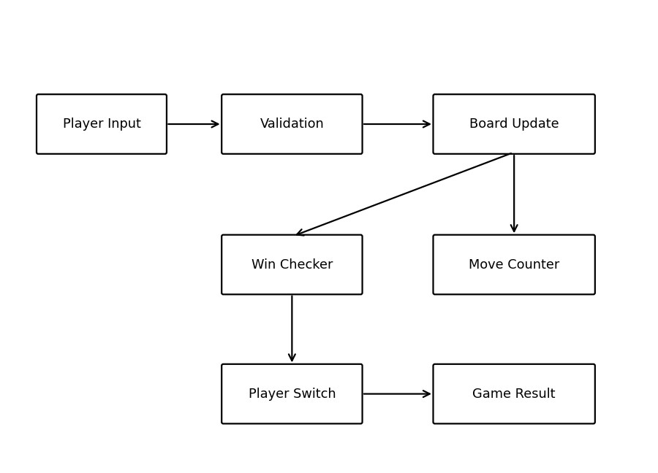

DESIGN DIAGRAMS
The workflow shows board initialization, input validation, move placement, win checking, player switching and the final result.
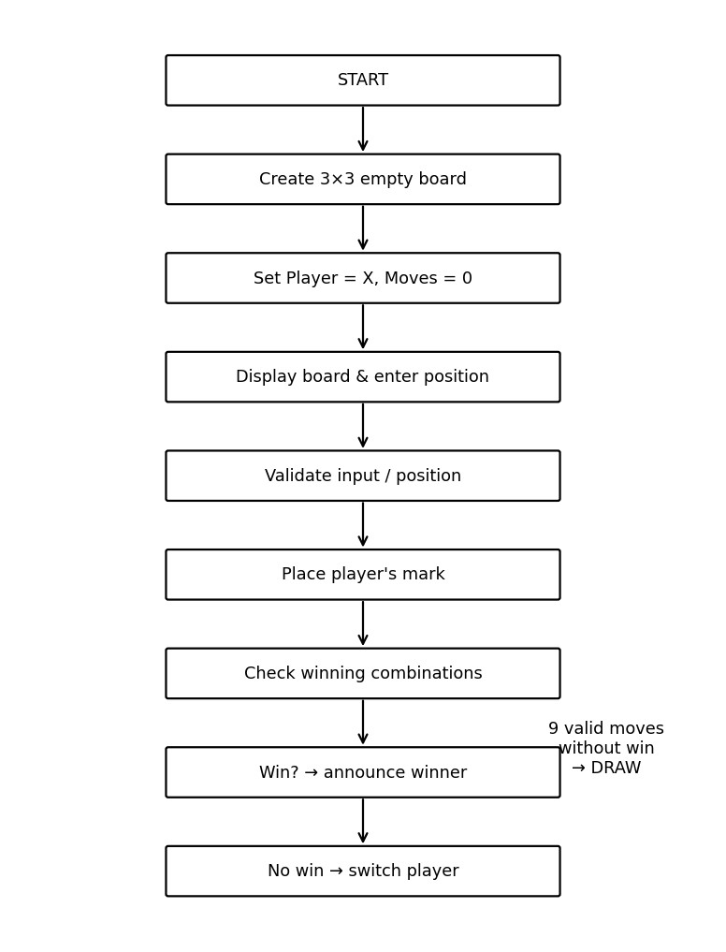

DESIGN DECISIONS & RATIONALE
- List for board: A nine-element list maps directly to positions 1–9.
- Functions: show() and win() keep major operations separate.
- Winning combinations: Eight tuples represent three rows, three columns and two diagonals.
- Exception handling: try-except handles non-numeric input.
- Move counter: moves ends the game after nine valid moves.

IMPLEMENTATION DETAILS
The board starts with nine blank strings. User position 1–9 is converted to a Python index 0–8.
After a valid move, the program checks whether the current player has won. If not, it switches between X and O.
The game loop continues while fewer than nine valid moves have been made.

FUNCTION IMPLEMENTATION
show() — displays the current 3×3 board. win(player) — checks all eight winning combinations.
Main loop — manages input, validation, moves, winning, switching and draw handling.

DATA STRUCTURE
The main data structure is a nine-element list named board. Each element stores a blank space, X or O.
1 | 2 | 3
4 | 5 | 6
7 | 8 | 9

ALGORITHM
- Initialize the empty board.
- Set player to X and moves to 0.
- Display the board.
- Ask for a position from 1 to 9.
- Reject non-numeric or out-of-range input.
- Reject an occupied position.
- Place the mark and increase moves.
- Check all eight winning combinations.
- If there is a winner, display the winner and stop.
- Otherwise switch player.
- If nine valid moves occur without a winner, display Game Draw.

TESTING APPROACH
The program can be tested using valid moves, invalid input, occupied positions, winning sequences and draw sequences.
Test Case | Condition | Expected Result
Valid move | Position 1 | X is placed
Non-numeric | abc | Error message; asks again
Out of range | 0 or 10 | Range error
Occupied | Used cell | Position already taken
Horizontal win | 1,2,3 | Player wins
Vertical win | 1,4,7 | Player wins
Diagonal win | 1,5,9 | Player wins
Draw | 9 moves, no win | Game Draw!

SAMPLE OUTPUT
The program displays the board, asks the current player for a position and prints the updated board after each valid move.
| |
--+---+--
| |
--+---+--
| |
Player X, enter a position (1-9): 1
X | |
--+---+--
| |
--+---+--
| |

CHALLENGES FACED
- Mapping positions 1–9 to indexes 0–8.
- Checking all rows, columns and diagonals.
- Handling non-numeric input.
- Preventing occupied positions.
- Ending correctly for wins and draws.

OUTPUT
The completed program provides a playable two-player command-line X and O game with validation, win detection, turn switching and draw detection.

LEARNINGS AND KEY TAKEAWAYS
- Practiced list creation and modification.
- Used Python functions for modular programming.
- Applied while loops and conditional statements.
- Used try-except for input handling.
- Used tuples to represent fixed winning combinations.
- Applied Boolean comparison of board positions.
- Understood how a simple interactive game can be divided into components.

FUTURE ENHANCEMENTS
- Add a graphical interface using Tkinter.
- Add a computer opponent.
- Add player names and score tracking.
- Add replay and restart options.
- Improve handling of unexpected inputs.
- Add sound and visual themes.

CONCLUSION
The Simple X and O Game combines lists, functions, loops, conditions and exception handling to create an interactive Python application. It is a practical demonstration of core programming concepts and game logic.

PROJECT SOURCE CODE
The project source consists of board initialization, show(), win() and the main game loop. The supplied implementation is compact and demonstrates core Python programming concepts.
board = [" " for _ in range(9)]
def show():
print(board[0], "|", board[1], "|", board[2]) print("--+---+--") print(board[3], "|", board[4], "|", board[5]) print("--+---+--") print(board[6], "|", board[7], "|", board[8])
def win(player):
combinations = [ (0,1,2), (3,4,5), (6,7,8),
(0,3,6), (1,4,7), (2,5,8),
(0,4,8), (2,4,6) ] for a,b,c in combinations: if board[a] == board[b] == board[c] == player:
return True return False
player = "X" moves = 0
while moves < 9:
show() try:
pos = int(input(f"Player {player}, enter a position (1-9): ")) - 1 except ValueError:
print("Please enter a number from 1 to 9.") continue if pos < 0 or pos >= 9:
print("Position must be from 1 to 9.") continue if board[pos] != " ":
print("Position already taken!")
continue board[pos] = player moves += 1 if win(player):
show() print(f"Player {player} wins!") break player = "O" if player == "X" else "X" else:
show() print("Game Draw!")

REFERENCES
- Python documentation — lists, functions, loops, conditionals and exception handling.
- Python programming course materials and classroom notes.
- Project source code supplied for this report.

